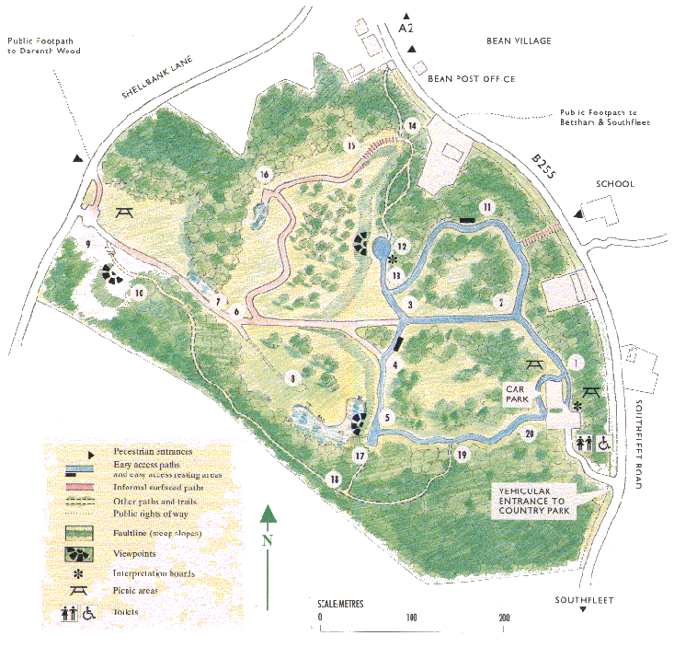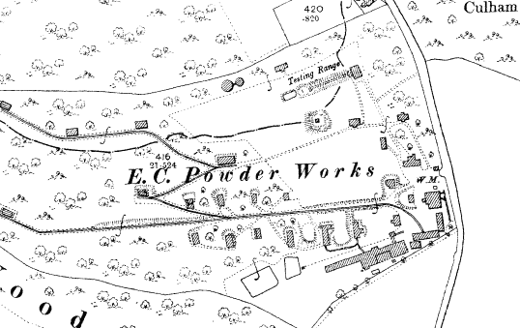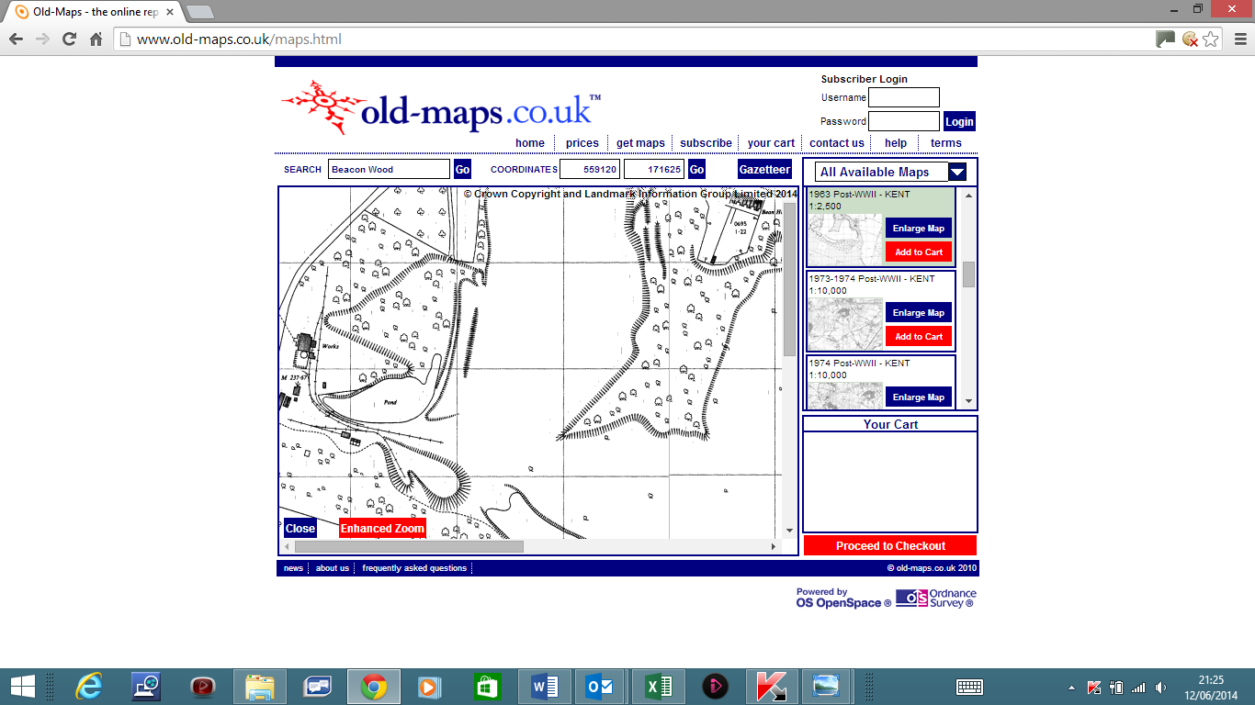

Clay Pit Buildings and Rail Tracks from 1963 OS Map

Powder Works Buildings, Tramways and Testing Range from 1909 OS Map

**BEACON WOOD COUNTRY PARK**Map from Visitors Guide January 1994

**BEACON WOOD COUNTRY PARK**

Map from Visitors Guide overlaid to show 1960’s Clay Pit and 1900’s Powder Works Industrial Heritage

http://www.users.waitrose.com/~beanra/history/beacon_wood-visitor_guide+powder%20works+clay_pit.docx